Confidential Patient Information

New Patient’s Name: Date: / /

Address City State Zip Cell Phone ( ) - Email address Date of Birth How did you hear about us? Occupation: Primary care physician contact information: Have you had X-Rays? □ Yes □ No Which body part(s)?
Where were they taken? Women only: Are you pregnant? □ Yes □No
Initial History: Please answer every question so we can provide you with the best possible service. If you have any questions or need help filling out this form, please ask one of the staff. We will be happy to assist you.
- What is your number one problem or the one area of greatest concern? (We will provide a section later in the form for additional or secondary concerns.)

- How did it occur?
- When did it occur? Has your condition gotten worse since it started? □ Yes □ No
- Which areas of the body are affected?
- Describe what it feels like:
□ sharp □ stabbing □ dull □ ache □ tightness □ pulling □ burning □ numbness
□ tingling □ pins & needles □ throbbing □ other:
- On the following scale please circle the intensity/severity of your pain:
(no pain) 1 2 3 4 5 6 7 8 9 10 (worst pain)
- Do your symptoms radiate or shoot to other areas? □ Yes □ No
  - If yes, where to?
- How often do you experience your symptoms?
  - Constantly (76-100% of the day) b) Frequently (51-75% of the day)
c) Occasionally (26-50% of the day) d) Intermittently (0-25% of the day)

NAME
PAIN CHART

DATE

Please mark on the body diagrams all areas of pain, discomfort, or altered sensation. Use the key below to identify quality of each:
A=ache B=burning E=electrical S=stabbing
P= pins and needles N= numb O= other T= throbbing
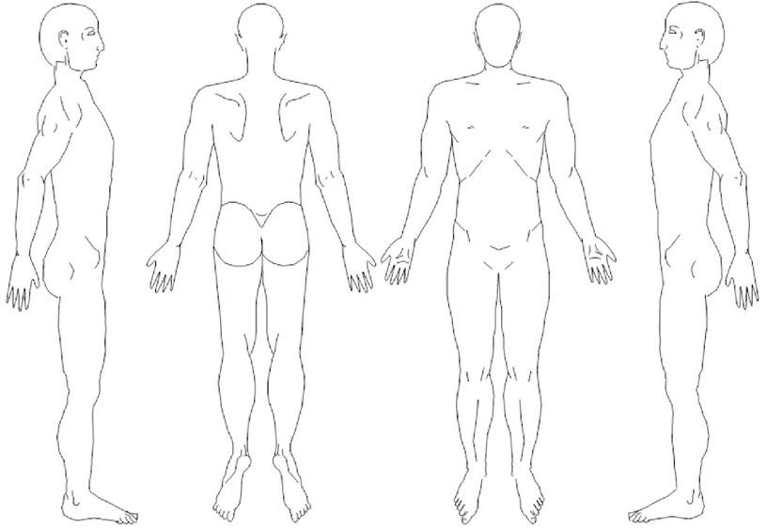

NOTES:

- List anything (activities, medication, etc.) that makes your condition better or
worse:

- Have you previously received chiropractic care? □ Yes □ No
  - If yes, from whom?
- Have you been treated for this complaint before? □ Yes □ No
  - If yes, by whom?
  - When was your treatment?
- Has your complaint caused a change or relationship with any other parts of your body? (e.g., hearing, vision, eating, sleeping, digestion, breathing, balance, strength, or other): □ Yes □ No
  - If yes, what
- During the past 4 weeks how much of the time has your condition interfered with you social activities?
  - All of the time b) Most of the time c) Some of the time
d) A little of the time e) None of the time
- Is your current complaint related to an accident? □ Yes □ No
  - If yes, was it from:
□ Auto □ Work Related □ Other (describe)
  - If work related, was your employer notified? - □ Yes □ No
  - Have you missed any work due to your accident? □ Yes □ No
- Have you had any trauma or accidents other than normal bumps and bruises? □ Yes □ No
  - If yes, what?
- Have you had any recent illnesses other than colds, flu? □ Yes □ No
  - If yes, what?
- Have you had surgery? □ Yes □ No
  - If yes, what?

- Do you take medication? □ Yes □ No
  - If yes, please list the medication(s) and what it is for:

- What are your physical demands at work? (lifting, sitting, standing, driving, walking, etc.)?

- Have you changed any of activities you participate in?

- Are these illnesses found in your family history? (check each that apply)
□ Arthritis □ Heart disease □ High blood pressure □ Kidney disease □ Tuberculosis
□ Allergies □ Thyroid disorders □ Cancer (type):

- Please mark any of the following you have had difficulty with:

- Numbness in arms or hands
- Pins & Needles in arms or hands
- Pain in arms or hands
- Pain in legs or feet
- Numbness in legs or feet
- Pins & Needles in legs or feet
- Headaches
- Disc problems
- Jaw problems
- Joint swelling
- Painful joints
- Arthritis
- Chest pains
- Heart problems
- High blood pressure
- Low blood pressure
- Sinus problems
- Dizziness
- Temporary disorientation or confusion
- Loss of consciousness or momentary blackouts
- Asthma
- Stomach problems
- Kidney problems
- Bladder problems
- Frequent urination
- Diabetes
- Gallbladder problems
- Cancer
- Fever
- Sleeping problems
- Tension
- Lights bother eyes
- Loss of balance
- Prostate problems
- Menstrual cramps
- Swollen ankles
□Unexplained weight loss
- Excessive fatigue
- Smoking
- Frequent illnesses
- Night pain
- Thyroid problems
- Anemia
- Hernia
- Weakness
- AIDS/HIV
- Blurred or double vision
- loss of vision in one or both eyes
- Ringing, buzzing or any noise in your ear(s)
- Recent hearing loss in one or both ears
- Slurred speech or other speech problems
- Difficulty swallowing
- Sudden severe pain in the side of your head and/or neck, which is different from pain you have had before
- Loss of taste or smell
- Stroke
- Loss of consciousness or momentary blackouts
- Numbness or loss of feeling in the face, fingers, hand, arms, legs, or other part of your body
- Weakness, clumsiness, or loss of strength in your face, fingers, hands, arms, or legs
- Sudden collapse without loss of consciousness

- Other (describe):

Secondary Concern Section: Please only fill out if you have a secondary area of concern that you would like to address with the doctor.
- What is your secondary complaint today?

- How did it occur?
- When did it occur? Has your condition gotten worse since it started? □ Yes □ No
- Which areas of the body are affected?
- Describe what it feels like:
□ sharp □ stabbing □ dull □ ache □ tightness □ pulling □ burning □ numbness
□ tingling □ pins & needles □ throbbing □ other:
- On the following scale please circle the intensity/severity of your pain:
(no pain) 1 2 3 4 5 6 7 8 9 10 (worst pain)
- Do your symptoms radiate or shoot to other areas? □ Yes □ No
  - If yes, where to?
- How often do you experience your symptoms?
  - Constantly (76-100% of the day) b) Frequently (51-75% of the day)
c) Occasionally (26-50% of the day) d) intermittently (0-25% of the day)
- List anything (activities, medication, etc.) that makes your condition better or
worse:

Consent to Treatment and Privacy Policy
I authorize Dr. Jessica Thompson to perform chiropractic adjustments, treatments and procedures. I further consent to examinations, consulting services, and diagnostic procedures rendered in conjunction with the adjustments, treatments, and procedures. Release of Information Dr. Jessica Thompson may disclose information from the patient’s records to doctors, hospitals, or others for continuous care and to any third party who requires that information in order to fulfill an obligation benefiting the patient. Initials

Responsibility for Payment
I acknowledge my responsibility to and agree to pay in full for the professional services rendered. I understand that if the doctor may bill my health insurer for the services, such billing does not relieve me of my responsibility to pay for the services. I also understand a charge will be made for broken appointments unless notice is given and the visit is made up at a later date. I agree to pay for any costs incurred as a result of sending my bill to a collection agency or any other legal action as well as 1.5% interest per month on any money owed for service rendered. Initials

Informed Consent of Risks
I understand that chiropractic care, as with any health intervention, has inherent risks. These risks, though rare, could occur ranging from a minor aggravation of current condition to serious conditions such as cerebral vascular accidents. I also understand that the doctor is not liable for any problems that might arise if I decide not to follow the treatment in which she prescribes. I understand and am informed that in the practice of chiropractic there are some risks, including but not limited to sprain and strain, fractures, dislocations, and general aggravations of inflammatory conditions. I understand that I will have an opportunity to discuss with the doctor and/or other office personnel the nature and purpose of the chiropractic procedures I will receive. I understand that the doctor will perform an examination in order to minimize any risk of care; however, I do not expect the doctor and/or intern to be able to anticipate and explain all risks and complications. I therefore wish to rely on the doctor to exercise judgment during the course of the procedure which the doctor and/or intern feels at the time, based upon the facts as then known, is in my best interest. Initials

Medicare Patients Authorization and Assignment of Benefits
I authorize payment of government benefits to Café of Life Chiropractic who accepts assignment for services covered by Medicare. I also understand it is my responsibility to pay for all other services which Medicare does not cover. Initials

CVA Signs
If during your visit you suffer from any of the following please notify the doctor or staff immediately:
- Sudden severe pain in the side of your head and/or neck
- Vision problems
- Numbness, loss of feeling, or abnormal feeling
- Weakness, clumsiness, or loss of strength
- Dizziness
- Hearing problems
- Disorientation or confusion
- Speech problems
- Loss of consciousness or momentary blackouts I have read, or have had read to me, the above consent and reviewed the information herein and represent that the same is true, correct and complete. I understand that the doctor is relying upon the information in rendering treatment. Initials

By signing below, I agree to the procedures. I intend this consent form to cover the entire course of care for my present condition(s) and for any future condition(s) for which I seek care. Privacy Policy (HIPPA) I acknowledge that Café of Life Chiropractic’s “Notice of Privacy Policies” has been provided to me. I understand that I have the right to review the Privacy Policy prior to signing this document. The Privacy Policy describes my rights with respect to my protected health information which is used for treatment, the payment of bills, and in the performance of health care operations of Café of Life Chiropractic. Café of Life Chiropractic reserves the right to change the privacy practices that are described in the “Notice of Privacy Policies”. I understand that I may obtain a revised copy of the policies by calling the office and requesting a copy or by asking for one at the time of my next appointment.

Signature: Date: Relationship to Patient:

